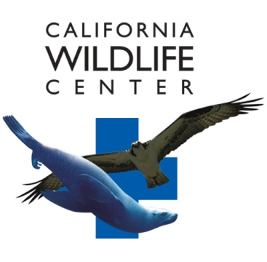
CWC Internship Requirements

CWC Wildlife Rehabilitation Internship

Responsibilities

During this unpaid Internship, you will assist staff and volunteers with all aspects of animal care including, but not limited to:

- Daily husbandry related activities including medical treatments, cleaning, diet preparation and
feeding in the Intensive Care Unit and the Baby Care Unit.
- Advanced animal care duties such as tube feeding, reading bloodwork, fracture stabilization, medication dosing, and subcutaneous fluid administration
- Assist with intake procedures for new patients
- Species identification and determining specific care requirements based on natural history and species behavior
- Safe handling of diverse species including raptors, pelagic birds, songbirds, and terrestrial mammals
- Assist in performing wildlife releases
- Responsible for animal enrichment program
- Learn about the natural history and behavior of native California wildlife
- Learn medical record keeping skills
- Assist in transporting wildlife from local animal shelters (desired but not required)

Housing/Transportation

Housing and transportation are the responsibility of the intern. There is no on site housing available.

Qualifications

- Must be 18 years of age or older
- Science, natural science, or animal care background required
- Must be able to perform physically demanding tasks such as cleaning, lifting, bending, stooping, etc
- Must have respect for wildlife and courtesy toward the public
- Must be able to work independently and as a team member
- Must be able to perform tedious tasks for long periods of time
- Must be able to work quickly and efficiently while following directions and procedures
- Must be able to multitask and work in a very stressful environment
- Must be able to work long hours with few breaks
- This is an unpaid internship

To Apply

Please submit a resume and your letter of intent to the email below. Your letter of intent must state the session you are applying for and detail interests, experience, housing accommodations, and overall availability. If you qualify, a telephone interview will be scheduled after your application has been received. If you have any questions, please email Denys Hemen at denys@cawildlife.org.

There is no deadline by which you must apply; positions for all sessions are filled on an ongoing basis as qualified candidates are found. However, Positions fill quickly so be sure to apply early.
Applications will be accepted beginning December 23rd, 2016, until all positions are filled.

Schedule/Time Commitment

There will be four sessions of approximately 10 weeks each.

The weekly requirement is 32hrs comprised of 4 shifts that are 8 hours each.

Each shift will be 7am – 3:30pm or 11:30am – 8pm.

Start dates are generally flexible within reason. Weekly time commitments can be adjusted at the Hospital Manager’s discretion.

Proposed session dates are:

Session 1: March 1 - May 7 (3 positions available)
Session 2: May 2- July 2 (7 positions available)
Session 3: June 19 - August 21 (7 positions available)
Session 4: August 14 - October 22 (2 positions available)

For additional information, please contact Denys Hemen by email at denys@cawildlife.org.

This program is under the direction of Denys Hemen, Hospital Manager.

Please include “Wildlife Rehabilitation Internship Application” in your subject line.

